Exploring Congestion Control Algorithms using Emulation
Notes:

Overview
TODO

2. Learning Objectives
- TODO.

3. Background
TCP (Transmission Control Protocol) congestion control is a mechanism that prevents too much data from being sent on a network too quickly. This is important because networks have limited bandwidth, and overwhelming them with too much data can lead to packet loss, long delays, and overall network congestion.
To experiment with congestion control, we use Mininet to emulate our Network. A network emulator is a tool that creates a real-time, interactive environment that behaves like a physical network. Unlike simulators, which model the theoretical behavior of networks through software algorithms and assumptions, emulators interact with real data packets and enforce network conditions onto them. This makes emulators particularly valuable for more realistic testing scenarios, where actual network stack implementations and hardware interfaces are involved.

Mininet emulates the nodes of a real network using “Hosts” and “Switches”. Each host and switch is contained in its own isolated virtual environment, running standard applications and network tools as if they were on separate physical machines. This is known as process-based virtualization.

To isolate each virtual environment, Mininet uses Linux network namespaces to create virtual instances of the network stack. Each network namespace provides a completely separate network environment, including network interfaces, IP routing tables, and sockets. The separation is such that the hosts and switches operating within their individual namespaces are unaware of each other's network interfaces and cannot directly communicate with each other, unless explicitly configured to do so.

When Mininet constructs a network topology, it typically creates a Virtual Ethernet (veth) pair to serve as the link between two hosts/switches. One end of the veth pair is placed in one namespace, and the other end is placed in another namespace. These veth pairs emulate direct Ethernet connections, and support all standard operations that can be performed on physical network interfaces.

Mininet uses Linux’s Traffic Control (tc) to shape, schedule, and police traffic along veth links. This allows us to introduce various network conditions, like specific bandwidths, latency, jitter, and packet loss. At the foundation of Linux Traffic Control are queuing disciplines (qdiscs), which are algorithms determining how packets are queued for transmission on a network interface. A qdisc can manage the packets directly or delegate to child qdiscs. For instance, to set the bandwidth and latency along a link, the Token Bucket Filter (TBF) qdisc is used to control the rate at which packets are sent (using its token bucket algorithm). Another qdisc, netem, is then added as a child qdisc. First, bandwidth limits are enforced by TBF, and afterwards netem holds packets within the queue to induce latency. Additionally, we can set the size of the queue. This allows us to manage how many packets we hold before there is packet loss, which can significantly affect the behavior of various TCP congestion algorithms.

4. Detailed Procedure

Connecting to VM via SSH.
Some of the software we are using requires X-forwarding to enable graphical user interfaces when accessed remotely, this allows us to interact with the application's graphical interface from a different machine. WITH DESKTOP MANAGER INSTALLED THIS SHOULDN’T BE NECESSARY ANYMORE.
- Connect to the virtual machine using VMware: VM > SSH > Connect to SSH.
Option | Description
Username | Enter the user name of the virtual machine: mininet
Port | Enter the correct port number: TODO
Options | Use the -Y option to enable trusted X11 forwarding

Setting up the environment.
- When you log in and start an X11 session, the X server creates an X authority file if it doesn't already exist. This file is usually located in the user's home directory, typically at ~/.Xauthority. When you use sudo, the environment variables, including the XAUTHORITY variable which points to the X authority file, might change to that of the root user. This means that when you attempt to use X-forwarding with sudo, the X server might not have permission to access the necessary credentials in the original user's ~/.Xauthority file. To enable X11 authentication, copy the authentication file into /root/:
mininet@mininet-vm:~$ sudo cp ~/.Xauthority /root/
WITH DESKTOP MANAGER INSTALLED THIS SHOULDN’T BE NECESSARY ANYMORE.

- To run our tests, we will use Python’s venv module. This allows us to create virtual Python environments – self-contained directories that contain a Python interpreter and a set of additional packages. A virtual environment named test should already exist on your machine. Activate it with the following command:
mininet@mininet-vm:~$ source test/bin/activate

If everything worked correctly, the virtual environment name should now show up in the command line:
(test) mininet@mininet-vm:~$

*Note: If you would like to create your own virtual environment see <TODO_file_name>.txt for more information

How can we identify congestion?
- You can run CongestionInspection using python with sudo privileges:
(test) mininet@mininet-vm:~$ sudo python3 cinspect.py

Let’s go over some sample output.
- The following shows information about the topology of the network, namely each node, network interface, and connection.

Using the following node connections:
c0
s1 lo: s1-eth1:s2-eth1 s1-eth2:h1-eth0
s2 lo: s2-eth1:s1-eth1 s2-eth2:h2-eth0
h1 h1-eth0:s1-eth2
h2 h2-eth0:s2-eth2

- Nodes s1 and s2 denote switches, h1 and h2 denote hosts, and c0 is the controller for s1 and s2.
- Listed beside each node are its interfaces, and their connections.
- For instance, reading s1’s information we can see it has three interfaces:
  - lo - this is its loopback interface, it does not connect to another interface.
  - s1-eth1 – this interface connects to another interface, s2-eth1.
  - s1-eth2 – this interface connects to another interface, h1-eth0.
Q1. Using this information, draw the topology of the network.
A1. 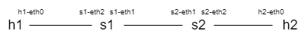
- Next is the tcp flow information provided by iperf3 (your own results may vary). It represents a 5 second flow from h1 to h2. For the following questions, be sure to note any relevant differences between the sample results, and your own.
**********Starting RTT test with iperf3 (5 seconds)**************

Sample result:
iperf 3.7
Linux mininet-vm 5.4.0-166-generic #183-Ubuntu SMP Mon Oct 2 11:28:33 UTC 2023 x86_64
Control connection MSS 1448
Time: Mon, 06 May 2024 21:28:43 GMT
Connecting to host 10.0.0.2, port 5001
Cookie: 3lcxv5ruzc7pqbmzo4boknqkg32bav7upicq
TCP MSS: 1448 (default)
[ 7] local 10.0.0.1 port 5201 connected to 10.0.0.2 port 5001
Starting Test: protocol: TCP, 1 streams, 131072 byte blocks, omitting 0 seconds, 5 second test, tos 0
[ ID] Interval Transfer Bitrate Retr Cwnd
[ 7] 0.00-1.00 sec 1.66 MBytes 13.9 Mbits/sec 0 160 KBytes
[ 7] 1.00-2.00 sec 1.49 MBytes 12.5 Mbits/sec 0 218 KBytes
[ 7] 2.00-3.00 sec 1.55 MBytes 13.0 Mbits/sec 0 276 KBytes
[ 7] 3.00-4.00 sec 636 KBytes 5.21 Mbits/sec 12 221 KBytes
[ 7] 4.00-5.00 sec 1.93 MBytes 16.2 Mbits/sec 0 253 KBytes
- - - - - - - - - - - - - - - - - - - - - - - - -
Test Complete. Summary Results:
[ ID] Interval Transfer Bitrate Retr
[ 7] 0.00-5.00 sec 7.25 MBytes 12.2 Mbits/sec 12 sender
[ 7] 0.00-5.23 sec 5.87 MBytes 9.41 Mbits/sec receiver
CPU Utilization: local/sender 1.5% (0.7%u/0.8%s), remote/receiver 1.4% (0.0%u/1.4%s)
snd_tcp_congestion cubic
rcv_tcp_congestion cubic

Q2. What is the maximum segment size of the network? What does this value represent?
A2. 1448 bytes. It represents the maximum amount of data that a device can receive in a single TCP segment without fragmentation.
Q3. Does this value make sense?
A3. The reported MSS of 1448 bytes is often seen in networks that use Ethernet as the underlying technology. In Ethernet networks, the Maximum Transmission Unit (MTU) is typically 1500 bytes. However, the MSS is reduced by 52 bytes to account for the the IP header (20 bytes), and the TCP header (32 bytes = minimum of 20 bytes + 12 bytes allocated for TCP timestamps).
https://www.noction.com/blog/tcp-header
- By default, iperf3 reports a variety of flow information in 1 second intervals:
  - The Transfer column represents the total amount of data transferred.
  - The Bitrate column represents the rate at which data is transmitted over the network.
  - The Retr column represents the number of retransmissions. Retransmissions occur when TCP segments are lost or not acknowledged by the receiver within a certain timeout period, prompting the sender to retransmit those segments
  - The Cwnd column represents the congestion window size.
Q4. Using the information provided by iperf, how can you tell the network is experiencing congestion? Make sure to support your answer with as much evidence as possible.

A4. There is congestion during the 3-4 second interval. This is supported by a drop in data transferred from 1.55 Mbytes to 636 Kbytes, a drop in bitrate from 13.0 Mbits/sec to 5.21 Mbits/sec, a drop in Cwnd from 276 Kbytes to 221 Kbytes, and 12 retransmissions.

Q5. Knowing that there is congestion in the network, what can you infer about the relative bandwidth capacity of the links connecting h1 and s1 compared to one or more of the remaining links in the network. Why is this causing congestion?

A5. The link connecting h1 and s1 has a higher bandwidth capacity than at least one of the links connecting s1 to s2, or s2 to h2. I.e. There is a bottleneck link in the network that is slower than the link connecting h1 to s1. The speed of packets traveling across h1 to s1 is causing congestion at the switch connected to the bottleneck link, due to the ingress of packets being faster than the egress, causing its buffer to overflow.

Q5. Iperf reports CUBIC as being the congestion algorithm of the sender and receiver. Is this a loss or delay-based algorithm? How do you know?

A5. It is a loss based algorithm
- Congestion window is steadily increasing and shrinks when experiencing loss. A loss-based algorithm would not continuously grow or react to loss like this.
- A delay-based algorithm should estimate the available bandwidth and prevent buffer overflows (as long as there are no other senders using a loss-based congestion algorithm). Since we only have one TCP flow in the network, a delay-based algorithm shouldn’t cause router buffers to overflow.

RTT, CWND, and Buffers
Let's run an extended test to get a clearer picture of our network's performance. We can use the -t option to specify how long we want to run the test, and the -d option lets us delay the iperf flow to get a round-trip time baseline. Let’s run a 20 second test with a 5 second delay:

(test) mininet@mininet-vm:~$ sudo python3 cinspect.py -t 20 -d 5

Once the program finishes running, look at the resulting graphs. 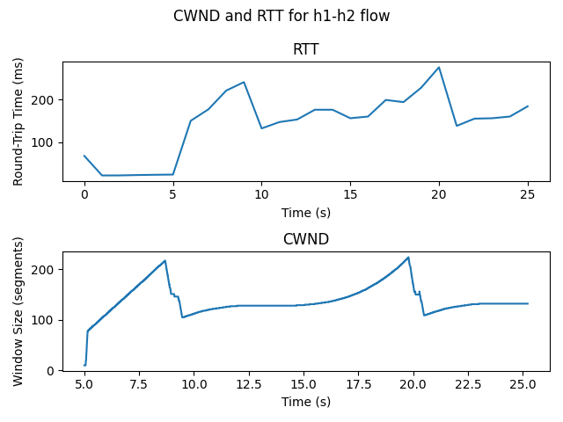
The first graph is the round-trip time, it is reported using the ping utility, and is also polled at one second intervals. The second is the CWND as reported by the linux kernel, it has a much lower granularity (increased precision) than the iperf CWND results.

Remember that loss-based congestion algorithms can be notified of packet loss by receiving triple duplicate ACKs, or due to a timeout in acknowledgements received.

Q6. Explain how triple duplicate ACKs differ from an acknowledgement timeout.

A6. Triple duplicate ACKs occur when the receiver receives a packet out of order and continues to acknowledge the last correctly received packet. After three duplicate ACKs for the same packet, the sender infers that a packet has likely been lost and fast retransmits. A timeout happens when a packet is lost, but no duplicate ACKs are received. The sender will eventually timeout waiting for an acknowledgement.

Q7. Look at the CWND graph. Can you infer if the window size is shrinking due to a timeout or due to receiving a triple-duplicate ACK?

A7. The window size shrinks due to a triple-duplicate ACK:
- The magnitude in CWND drops is more consistent with that of a triple duplicate ACK. In a timeout, the CWND size would have a drastic reduction to 1 or 2 segments.
- The increase in CWND just prior to window size dropping, also indicates triple duplicate ACKs. The increase in CWND is driven by the receipt of ACKs, with each acknowledgement received increasing the CWND of the sender. In the absence of ACKs (as would be the case in a timeout), the sender would instead stop increasing the CWND, and start counting down to the retransmission timeout.

Q8. Look at the RTT graph. Remember that RTT is the time it takes for a signal to travel from the sender to the receiver and back. Why does the RTT appear to be scaling with the window size? Is this a direct or indirect relationship? Hint: Think about what is happening to the buffer connected to the bottleneck link when the congestion window grows, versus when it shrinks.

A8. The RTT appears to be scaling with CWND magnitude due to the CWND’s effect on the buffer occupancy level. As the CWND increases in size, so does the buffer occupancy level. This in turn causes RTT to increase, as packets spend more time waiting to be dequeued from the buffer. Once the buffer overflows and the sender decreases its CWND, the buffer occupancy decreases which reduces the queuing delay, subsequently reducing the RTT. The RTT is therefore indirectly affected by the CWND, and directly affected by buffer occupancy.

Exploring the test data
- You may have noticed that the program prints out a directory path where further results can be found. Navigate to this directory now. Within this directory you should see several files:
$ ls
ftrace_raw.txt h1_h2 h1_tcpdump.pcap

The ftrace_raw.txt is a copy of a circular buffer managed by the kernel to store data collected by the Ftrace framework. Although Ftrace goes beyond the scope of our course, one of its main capabilities is dynamic tracing of kernel code using trace events or tracepoints. The Linux kernel provides trace events at specific points throughout the kernel, like scheduling, memory management, network-related activities, and more. When the kernel executes code associated with an enabled trace event, data relevant to the trace event is collected and recorded in a trace buffer. Cinspect uses the tcp_probe trace event to collect trace data relevant to TCP-related events.
Examine the first 20 entries of ftrace_raw.txt using the head command. What type of information collected by the tcp_probe trace event may have been used to generate the previous graphs?
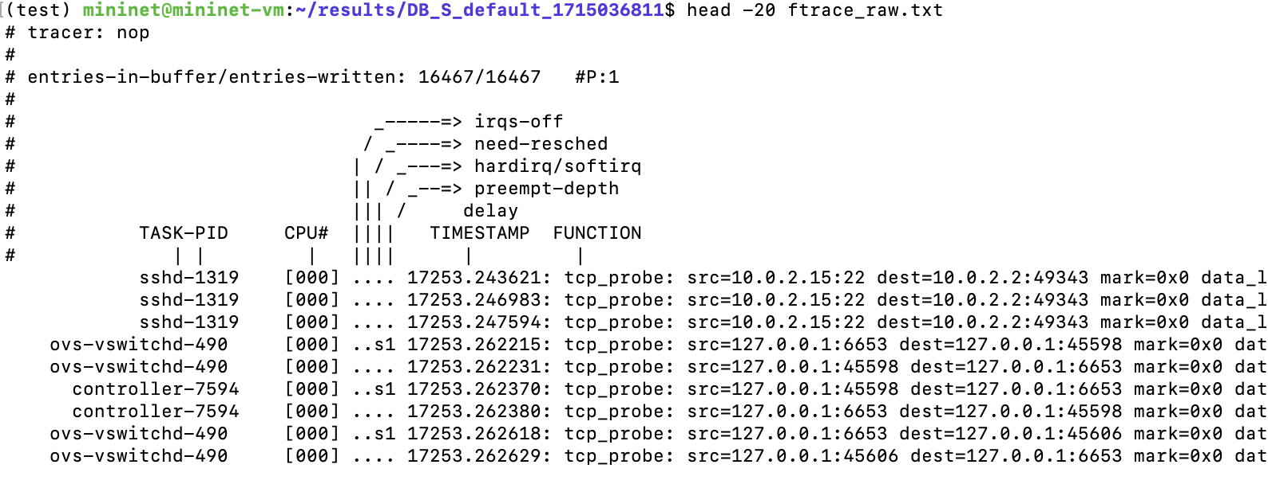
The h1_tcpdump.pcap is a packet capture of h1’s network traffic collected using tcpdump. You can examine its contents using wireshark.
Navigating into h1_h2 we see data related to one specific flow between two nodes, in this case h1 and h2.
  - ftrace.csv – A subset of the flow’s tcp_probe trace event data from ftrace_raw.txt
  - graph.png – The matplotlib graphs we examined earlier.
  - ping.txt – The ping output from h1 to h2.
  - ping.csv – The collected RTT’s in ping.txt converted to csv format.
- To continue working with these files, transfer them to your physical machine. You can do this using scp:
$ scp -r -P <port> mininet@127.0.0.1:<path to directory> ~/

Familiarize yourself with the ping.csv and ftrace.csv data.

How does CUBIC function?
Q10. Describe the following parameters related to CUBIC congestion control (can students do this?)
  - Slow start
  - Congestion avoidance
  - Logarithmic growth
  - Exponential growth
  - SSTHRESH
  - Wmax

A10. TODO

Q11. Using the information provided in the csv files and your graphing software of choice, plot the CWND, RTT, and SSTHRESH over time on the same graph. Additionally, try and annotate each parameter listed in Q10. Note that SSTHRESH and CWND share the same units (segments). RTT uses separate units, so you should have two labelled Y-axes. Also note that you do not need to include the full test duration. Only include enough to highlight CUBIC behavior in the presence of congestion, as well as each of the parameters. If you are unsure of what graphing software to use, Plotly’s online graph maker has all the functionality you will need.

A11. 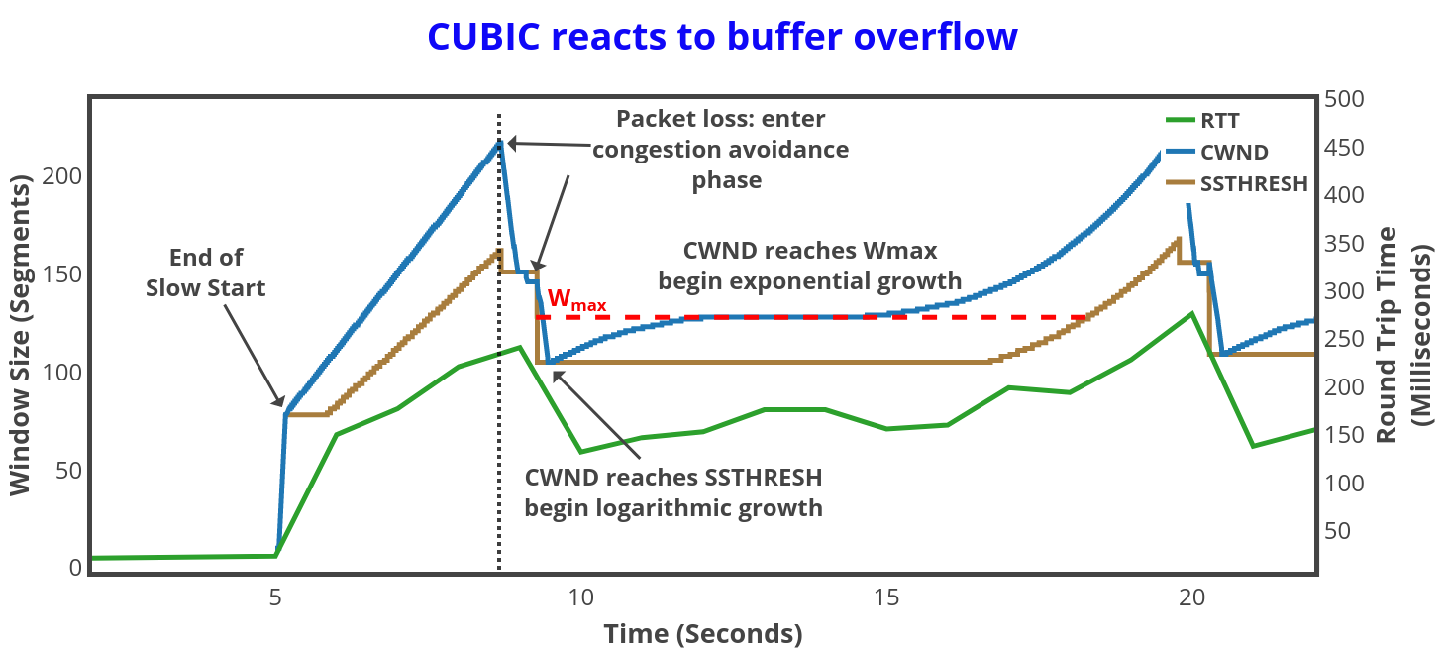
Q12. Did your graph correctly exhibit each of the CUBIC parameters? Discuss any strange behavior you observed.

Q13. One of CUBIC’s most notable features is its distinctive growth relative to Wmax. Explain why this is beneficial in congestion control.

A13. CUBIC grows slowly toward Wmax. This provides stability, as the window size does not fluctuate too aggressively around the peak value, avoiding unnecessary congestion. After passing Wmax, CUBIC grows very rapidly as it moves away. This allows it to efficiently probe for additional available bandwidth by expanding the congestion window more aggressively when there is potential for more capacity.

Q14. In your tcp flow, is CUBIC utilizing Wmax effectively? If not, what could be causing this?

A14. I’m not sure myself. It seems like Wmax is attempting to approximate the available bandwidth * RTT (BDP), since this is where it is most desirable to have a stable transmission rate. Since the network being emulated is static (the available bandwidth and RTT always remains the same), if it was being utilized effectively, we would be experiencing congestion close to Wmax where stability is highest. Instead, congestion occurs during the exponential growth away from Wmax, creating unnecessary congestion.
One reason for this could be that the buffer size is too large (even though this is the “small” buffer test). With a large buffer the disparity in CWND size compared to actual bandwidth capacity is increased, because the buffer takes longer to overflow, delaying packet loss feedback. Once loss occurs, the magnitude in which the CWND shrinks is not sufficient for the level of congestion, due to the increased disparity in CWND size and bandwidth capacity. Subsequently, there are multiple congestion events causing the CWND to shrink multiple times before being below bandwidth capacity, potentially over adjusting the CWND size. Additionally, once the CWND size is below BDP, packets travelling on the wire may still be incoming above this rate for a short period, still causing additional congestion events. As a result, the last congestion event may not be representative of the BDP, causing Wmax to be inaccurate.

Big buffers
- Return to the cinspect source directory and open up dumbbell.py in your editor of choice. Examine the LINK_CONFIG constant. It stores a dictionary containing link configurations for the dumbbell topology class. Each object in the dictionary contains an array of configurations for exactly three links.
      - The first element is the link configuration for all links connecting nodes to the switch left of the bottleneck link.
      - The second element is the link configuration for the bottleneck link, connecting the left and right switches together.
      - The third element is the link configuration for all links connecting nodes to the switch right of the bottleneck link.

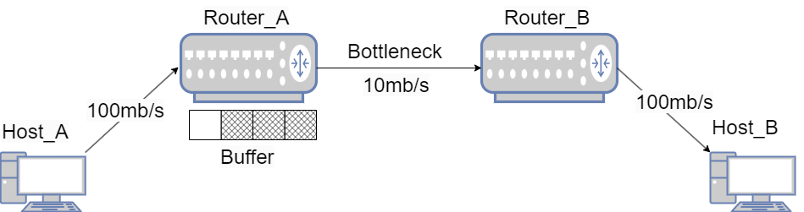

Q15. What’s the difference between the DB_S and DB_L configuration? Using the above diagram, what do you think this parameter represents?

A15. DB_S has a max_queue_size of 100 and DB_L has a max_queue_size of 10000. Max_queue_size represents the capacity of Router A’s egress buffer.

Q16. By default, cinspect uses the DB_S configuration. How do you think the network will react when we run the previous test using the DB_L configuration?

A16. Omitted.

- You can specify which link configuration you want to use when running cinspect with the -l option followed by the name of the configuration.
If you’d like to experiment with different link configuration settings, simply create a new configuration and add it to LINK_CONFIG in dumbbell.py.

Run the same test as before, but this time with the DB_L configuration.

$ sudo python3 cinspect.py -t 20 -d 5 -l DB_L

Q17. Based on the iperf CWND and Retr values, does there appear to be congestion in the network?

A17. No

Q18. Examine the cinspect generated graphs. What’s wrong with the graphs? *Hint: Carefully consider each optional arguments used when running cinspect.

A18. We selected a test runtime of 20 seconds. This means the graphs should end approximately at the 25 second mark (20 sec test + 5 sec delay). However, they appear to go beyond 35 seconds.

Q19. At what point in time does RTT peak? When does CWND peak? Considering the relationship between CWND and RTT, why does this behavior seem strange?

A19. RTT peaks shortly after 25 seconds, and CWND peaks at the 35 second mark. This doesn’t make sense as CWND should be continuously increasing buffer occupancy, therefore increasing RTT.

Q20. Examine the iperf summary results. What are the sender and receiver time interval values?

A20. Sender: 0 – 20 sec. Receiver: 0 – 29.92 sec.

Q21. The sender Interval value is the time interval during which the sender sent packets to the receiver. The receiver Interval value is the time interval during which the receiver responds with corresponding acknowledgements. Knowing this, explain why it is taking so long for the receiver to receive and acknowledge the senders’ packets. Reference the topography diagram above to help in your explanation.

A21. The large buffer in Router A allows for additional buildup of packets, made worse by delaying packet loss and inflating the congestion window (CWND). This results in substantial queuing delays, extending the time it takes for the sender to receive acknowledgments.

Q22. Why do the discrepancies between the RTT and CWND appear more reasonable now?

A22. The sender is receiving acknowledgments after the 25 second mark, during which it still increases its CWND even though it is no longer sending packets. This is why the RTT starts to drop shortly after this point.

Q23. This network is experiencing bufferbloat. This occurs when there is excessive latency in network communications caused by oversized buffers. Consider the maximum RTT. Can you think of any applications that would be negatively impacted in a network like this? What about applications where large buffers are preferable to packet loss? Explain your reasoning.

A23. Real-time applications would be negatively affected. Bulk data applications managing large-scale transfers may prefer large buffers, where completing data transfers is more important than achieving low latency.

Add a screenshot of your cinspect generated graphs for the DB_L network. Also add your iperf summary results:

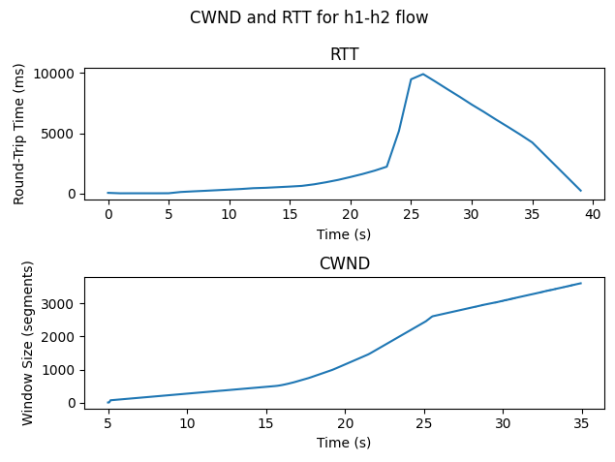

Test Complete. Summary Results:
[ ID] Interval Transfer Bitrate Retr
[ 7] 0.00-20.00 sec 32.2 MBytes 13.5 Mbits/sec 0 sender
[ 7] 0.00-29.92 sec 26.0 MBytes 7.28 Mbits/sec receiver

ADDITIONAL SCENARIO THAT COULD BE INTERESTING FOR STUDENTS:

- Highlighting that total transferred data is the same when using small and large buffers:
    - 1. Compare sender “Transfer” values in summary results between large buffer and small buffer test. (My values 32.2Mbytes vs 23.2 Mbytes)
    - 2. Highlight that the packets only arrived at receiver by the max time specified in receiver interval in the iperf summary results. Compare this with the small buffer test (It takes approx 30 seconds for all packets to arrive at receiver with the big buffer, and like 20.2 seconds with the small buffer).
    - 3. Rerun the small buffer test, but change the runtime to the receiver max interval value (this should be approx 29-30 seconds, make sure to round to the nearest integer)
    - Compare the sender transfer value to that of the big buffer value. (For me with the small buffer, sender sent 35.3Mbytes in 30 seconds, the receiver finished acknowledging after 30.17 seconds vs big buffer sender sent 32.2 Mbytes in 20 seconds and receiver acknowledged after 29.92 seconds)
    - Receiver is receiving approximately the same amount of data with the small and large buffer

Delay-based algorithms
- Show students how to change the congestion algorithm used

You can change the congestion algorithm using the -a option. Currently, you can run cinspect with bbr, reno, and cubic. (Verified algorithms: reno, cubic, lp, bbr, hybla, highspeed, cdg, dctcp, illinois, nv, scalable, vegas, veno, westwood. NOTE: STILL NEED TO UPDATE CODE TO BE ABLE TO USE THESE)

sudo python3 cinspect.py -t 20 -d 5 -l DB_L -a bbr

- Ask students to hypothesize what will happen when running the big buffer link config with BBR
- Run big buffer test with BBR
- Explain that BBR tries to approximate BDP
  - BDP is the maximum amount of data that can be in-flight but not yet acknowledged
  - In order to prevent buffer build up, must send below BDP – queueing delay.
  - BDP = Bottleneck Bandwidth * (RTT – queueing delay)
  - Given that the network has a 20 ms base RTT (this is the minimum amount of delay in the network, according to the link configuration), and the bottleneck bandwidth is 10Mbits/sec what is the optimal CWND size (in segments) for this network?

Answer:
MSS = 1448 bytes
RTT = 0.02 seconds
Bandwidth = 10,000,000 bps / 8 = 1250000 bytes/sec
BDP = 1250000 bytes/sec * 0.02 seconds = 25000 bytes

CWND = BDP/MSS = 17.3 segments
  - To do this BBR probes bandwidth and minimum RTT sequentially
  - Why are results different? *talk with maryam
  - Why is buffer not overflowing? *talk with maryam
    - 30 sec test with buffer size of 18, and bbr stops overflowing buffer
    - Drains every 10 seconds
  - I feel like this might help: https://www.ietf.org/proceedings/97/slides/slides-97-iccrg-bbr-congestion-control-02.pdf

- Contrast between CUBIC RTT and CWND magnitudes

- List and define each phase in BBR (can students do this?)
  - Startup: discover full capacity of the network
  - Drain: eliminate built up buffers
  - ProbeBW: maintain throughput while minimizing buffer occupancy
  - ProbeRTT: drain buffer and update minimum RTT
- Create graphs and annotate them using BBR phases

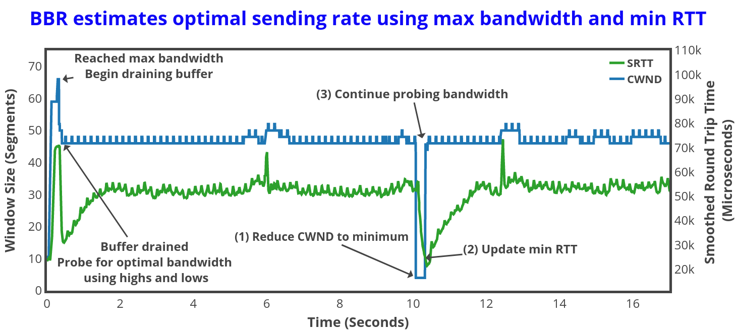

- Ask students to hypothesize how BBR will perform with small buffers
- Run BBR with small buffer size
- Highlight how BBR performs exactly the same, and doesn’t change according to buffer size

Networks are complex
- Show students how to run program with multiple hosts sending/receiving, each with a different congestion algorithm

Running both bbr and cubic:

- Use -n to specify number of sender/receiver pairs
- Pass comma separated algorithm, delays

sudo python3 cinspect.py -t 20 -d 5,6 -l DB_L -a bbr,cubic

- CUBIC shows useful Wmax in this example

- Make a note about how BBR can no longer predict bandwidth, and that it is not possible to rely solely on congestion control in an uncontrolled environment. Calibrating buffer size is important!
- Things that could be explored:
  - Fairness
  - Stability
  - Efficiency

5. Deliverables

https://docs.python.org/3/library/venv.html
https://iperf.fr/
https://en.wikipedia.org/wiki/Maximum_segment_size
https://en.wikipedia.org/wiki/CUBIC_TCP
https://www.man7.org/linux/man-pages/man8/ping.8.html
https://www.kernel.org/doc/html/v5.0/trace/ftrace.html
https://docs.kernel.org/trace/events.html
https://www.wireshark.org/
https://www.tcpdump.org/
https://www.man7.org/linux/man-pages/man1/scp.1.html
https://en.wikipedia.org/wiki/TCP_congestion_control
https://mininet.org/overview/
https://www.man7.org/linux/man-pages/man7/network_namespaces.7.html
https://www.man7.org/linux/man-pages/man8/tc.8.html
https://en.wikipedia.org/wiki/Token_bucket
https://manpages.ubuntu.com/manpages/focal/en/man8/tc-netem.8.html
https://en.wikipedia.org/wiki/Bufferbloat
https://www.ietf.org/archive/id/draft-cardwell-iccrg-bbr-congestion-control-01.html
https://www.man7.org/linux/man-pages/man4/veth.4.html

